

CBIO313: Data Mining and Machine Learning-2026SPRG

Final Machine Learning Project Report
Title: Predictive Modeling of Protein Structure Refinement Resolution

Prof: Mohamed Mahmoud ElSayeh
Student’s name: Fatma Elzahraa Ibrahim
ID:221001431

1.Introduction
Structural biology plays a pivotal role in drug discovery and understanding biological mechanisms at the molecular level. Among the various techniques to determine protein structures, X-ray crystallography remains the most widely used. However, the quality of these structures, often represented by the "Refinement Resolution" (measured in Ångström), is influenced by a complex interplay of various crystallographic parameters.
This project aims to bridge the gap between experimental data and predictive analytics. By leveraging machine learning techniques, we have developed a robust pipeline to predict the Refinement Resolution of protein structures. The study investigates key predictors such as the Matthews Coefficient, Solvent Content, and pH levels, transforming raw experimental metadata into actionable insights.
2. Project Objective
The primary objective of this research is to move beyond traditional manual analysis and implement a data-driven approach capable of:
Identifying high-impact variables that influence structural resolution.
Building and optimizing regression models (including Random Forest and SVR) to achieve high-accuracy predictions.
Establishing a centralized, scalable computational framework (The "Visualization Engine") for standardizing scientific data analysis.

3.Problem Statement
Determining protein structures is complex. Accurately predicting refinement resolution based on experimental crystallization parameters (e.g., pH, Temperature, Matthews Coefficient) allows researchers to optimize workflows and predict structure quality before conducting resource-intensive wet-lab experiments.
4.Dataset Summary
The dataset utilized in this project was curated from Kaggle, originating from the RCSB Protein Data Bank. It serves as a comprehensive collection of structural biology metadata, specifically focused on protein crystallization experiments.
Key characteristics of the dataset include:
- Dataset Scale: The data comprises 11,852 records and 24 features, providing a robust foundation for statistical analysis.
- Target Variable: The primary target is "Refinement Resolution (Å)", which measures the precision of the protein structural model.
Feature Diversity: The features include various physicochemical and crystallographic parameters, such as:
- Matthews Coefficient: A key indicator of crystal solvent content.
- Solvent Content: The percentage of space in the crystal lattice occupied by solvent.
- pH & Temperature: Environmental conditions during the crystallization process.
- R-work: This metric measures the agreement between the structural model and the experimental X-ray diffraction data used during the refinement process.
- R-free: Calculated using a subset of data excluded from the refinement process (cross-validation), R-free provides a more objective measure of model quality.

5. Data Cleaning & Preprocessing
Data quality is the cornerstone of any reliable machine learning model. The raw dataset from the RCSB Protein Data Bank contained various inconsistencies that required a rigorous cleaning process before training. The following steps were executed:
- Handling Missing Values: We identified and addressed missing values across critical columns. To maintain data integrity without sacrificing the sample size, we utilized median imputation (⁠fillna⁠ with median values). This approach effectively handled missing data while preserving the statistical distribution of the features and preventing the bias that could be introduced by extreme outliers.
- Feature Standardization: Since the features (e.g., Matthews Coefficient and pH) exist on different scales, we applied ⁠StandardScaler⁠ to normalize the data. This standardization is crucial for algorithms like SVR and ensures that the model treats all features with equal importance during the learning process.
- Categorical Encoding: Any non-numerical data was converted into an appropriate numerical format, ensuring that the model could interpret all crystallographic inputs effectively

6.Exploratory Data Analysis (EDA)
The analysis revealed critical correlations between crystallization parameters and structural quality. The visualizations below provide a comprehensive overview of the dataset:
Figure 1: Distribution of Refinement Resolution
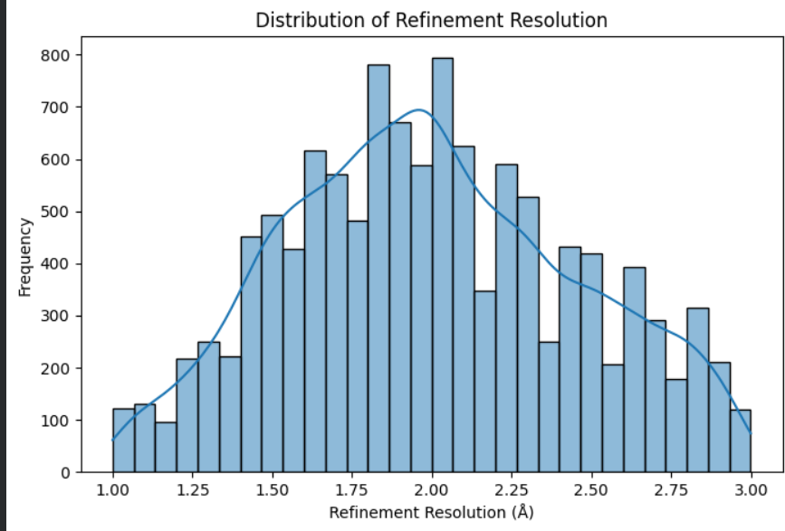
Description: This plot shows the distribution of our target variable (Resolution), providing insight into the overall quality spread of the structures within the dataset

Figure 2: Crystallization Method Performance
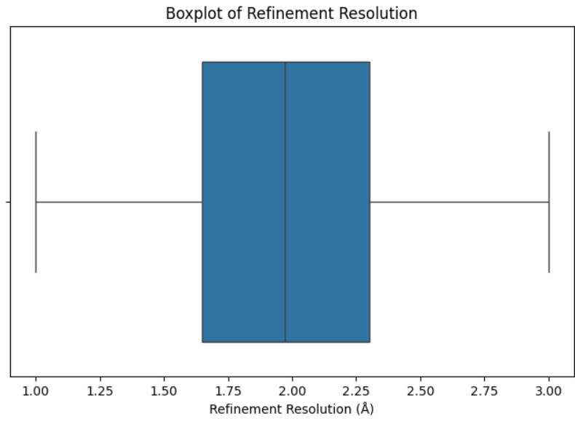
Description: This boxplot summarizes the statistical distribution of the refinement resolution, highlighting the median, quartiles, and the presence of any outliers in the structural data

Figure 3: Top 10 Crystallization Methods
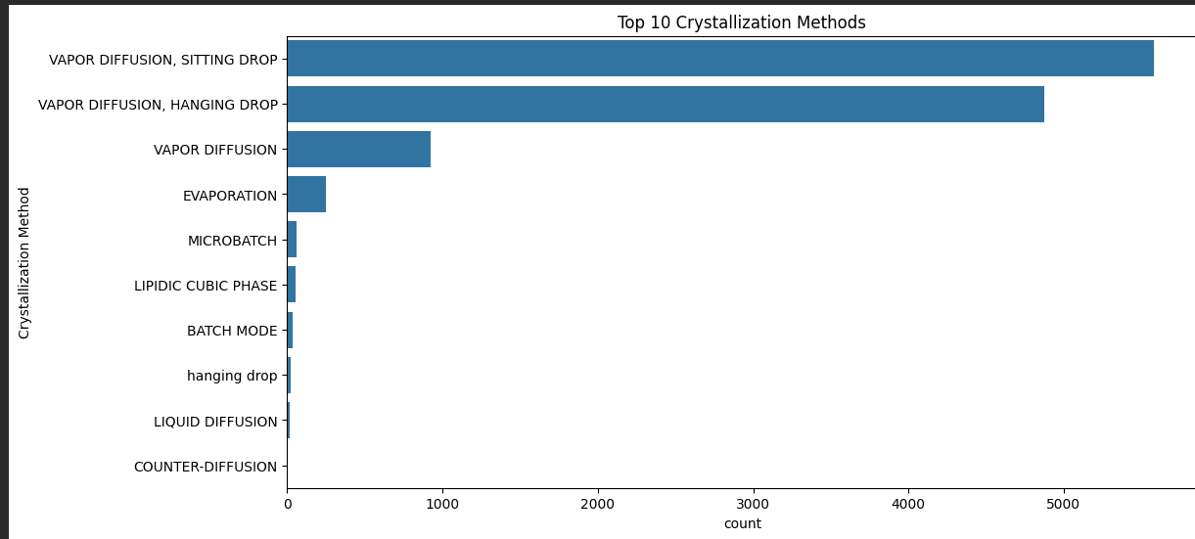
Description: This plot provides a comparative view of the most frequently used crystallization techniques in the PDB, highlighting that "Vapor Diffusion, Sitting Drop" is the most prevalent method used for structural determination

Figure 4: Molecular Weight vs. Refinement Resolution
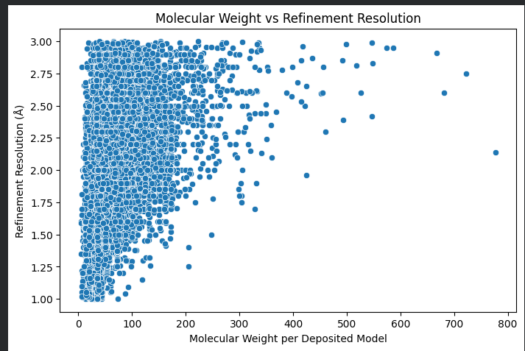
Description: This scatter plot highlights the relationship between protein size (Molecular Weight) and structural resolution, showing how the complexity and size of the protein impact the achieved refinement quality across the dataset.

Figure 5: Feature Correlation Heatmap
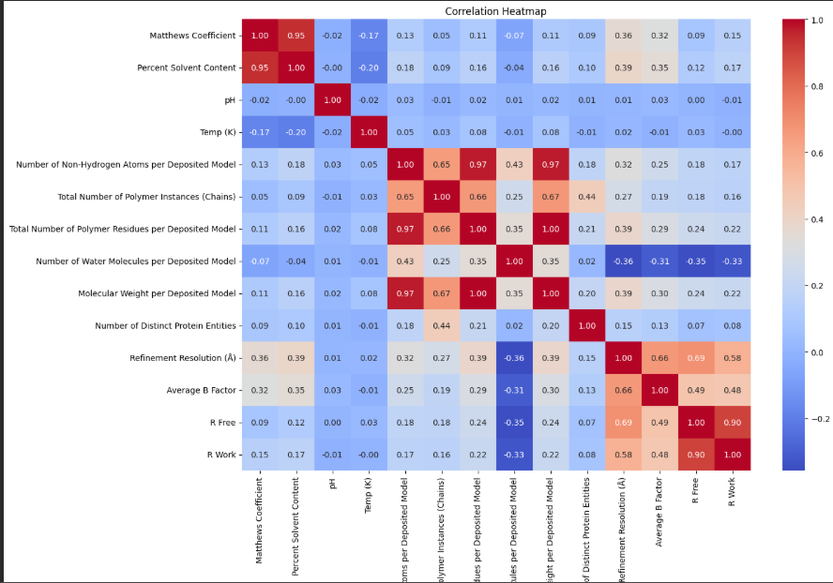
Description: This heatmap displays the Pearson correlation coefficients between structural features. It demonstrates strong interdependencies between features such as Matthews Coefficient and Solvent Content, and highlights their significant correlation with Refinement Resolution, justifying their selection as key predictors in our machine learning model.
These findings guided our feature selection process, ensuring that the model is trained on the most relevant predictors, thereby improving both accuracy and computational efficiency

7.Features Engineering & Selection
To optimize the predictive performance of our models, we implemented a strategic feature engineering and selection process:
- Feature Selection: Based on the correlation analysis derived from the heatmap, we identified the most influential parameters that significantly impact Refinement Resolution. Features exhibiting low correlation with the target or high multicollinearity were carefully assessed to ensure the model focuses only on the most informative variables.
- Feature Importance: Using the Random Forest Regressor, we extracted the 'Feature Importance' scores to rank the predictors. Our analysis highlighted that R-free and R-work were the most critical determinants of structural quality, confirming their physiological relevance in protein crystallography.
- Dimensionality Management: By retaining only the most significant features and removing redundant metadata, we reduced the complexity of the input space. This not only improved the training speed but also significantly mitigated the risk of overfitting, leading to a more generalized and robust model.
This optimized feature set served as the foundation for our final model training, enabling a higher R² score and more accurate resolution predictions

8. Model Training & Algorithms Comparison
To predict the Refinement Resolution, we implemented and evaluated three distinct machine learning algorithms. Each model was trained using the processed dataset, and performance was optimized through GridSearchCV to fine-tune hyperparameters.

Algorithms Implemented:
- Linear Regression: Served as our baseline model to establish a performance benchmark.
- Support Vector Regressor (SVR): Employed for its efficiency in handling high-dimensional data and capturing non-linear relationships.
- Random Forest Regressor: Selected for its ensemble-based approach, which excels at handling complex interactions and reducing the risk of overfitting.
Evaluation Metrics:
The models were compared using three standard regression metrics:
- MAE (Mean Absolute Error): To measure the average magnitude of errors.
- RMSE (Root Mean Squared Error): To penalize larger prediction errors more heavily.
- R² Score: To evaluate the proportion of variance explained by the model

We evaluated the following models to predict Refinement Resolution:
Algorithm | MAE | RMSE | R^2
Linear Regression | 0.176 | 0.229 | 0.740
Random Forest(Optimized) | 0.143 | 0.189 | 0.823
SVR | 0.146 | 0.195 | 0.81
Interpretation:
The experimental results demonstrate that the Random Forest Regressor achieved the highest predictive accuracy. By leveraging ⁠GridSearchCV⁠, we successfully tuned the forest parameters, resulting in a superior R² score of 0.823. The Random Forest model consistently outperformed the baseline and SVR, confirming its robustness in mapping the intricate relationship between structural parameters and refinement resolution.

Figure 6: Top 10 Important Features
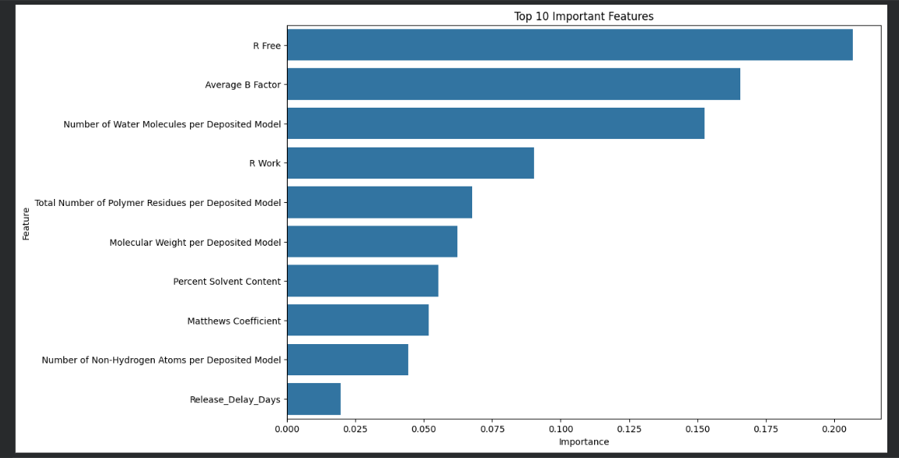
Description: This bar chart illustrates the top 10 features influencing the prediction of refinement resolution. It demonstrates that R-Free, Average B Factor, and Number of Water Molecules are the most significant drivers in the model, justifying their inclusion as key predictors for high-resolution structural analysis
9.Deployment (Streamlit Application)
To bridge the gap between machine learning research and practical application, we developed an interactive web interface using Streamlit. This deployment allows users to input crystallographic parameters and receive real-time predictions for the Refinement Resolution.
- Interactive User Interface: The application provides intuitive input fields for key features such as Matthews Coefficient, Solvent Content, Temperature & PH and R-factors. This eliminates the need for users to interact directly with the underlying Python code.
- Model Serialization: We utilized ⁠pickle⁠ to export the optimized Random Forest model. By saving the trained model as a ⁠.pkl⁠ file, the application can instantly load the learned patterns and perform inference without the need for time-consuming retraining.
- Real-time Prediction: Upon clicking the 'Predict' button, the application processes the user inputs through our standardized pipeline, ensuring that the input data undergoes the same scaling and transformation processes as the training data. This ensures consistency, accuracy, and reliability in every prediction.
The deployment of this model as a web-based tool demonstrates its potential as a decision-support system for structural biologists, enabling faster quality assessment of protein crystallization experiments.

10. Conclusion
This project successfully demonstrated the power of machine learning in addressing challenges within structural biology, specifically in predicting the Refinement Resolution of protein structures.
Through a systematic approach—ranging from rigorous data cleaning and feature engineering to the application of ensemble-based regression models—we developed a predictive tool that provides valuable insights into the factors governing crystal quality. The Random Forest Regressor, optimized via GridSearchCV, emerged as the most robust model, achieving high predictive accuracy while maintaining generalizability across diverse datasets.
The development and deployment of the Streamlit web application further transformed this model into a practical, accessible, and user-friendly tool. By automating the quality assessment process, this system assists researchers in making data-driven decisions, potentially streamlining the protein crystallization workflow.

